**Assignment Report**

**Problem 1**

**Name:** Jannatul Fardaush Mithu

**ID:** 1721769642

**Course:** CSE445

**SEC:** 03

**Semester:** Spring21

**Task 1:**

**Graph:**

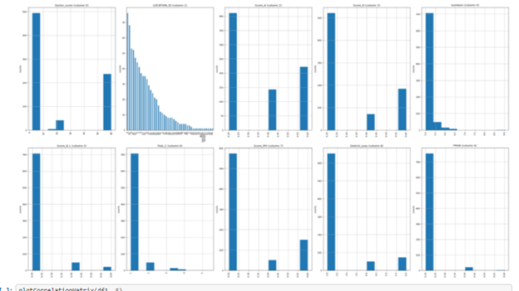

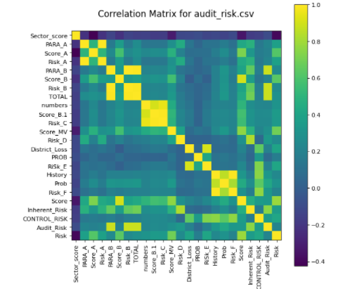

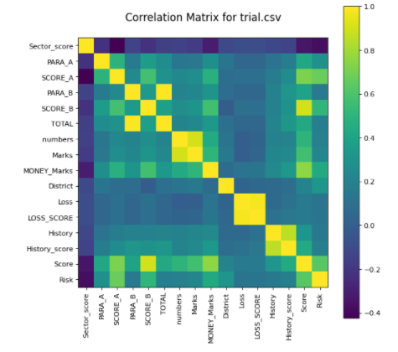

**Table:**

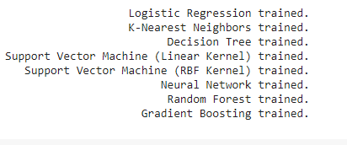

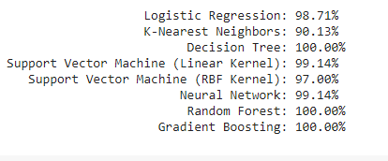

**GitHub link -** https://github.com/jannatuljannat/jannatul-1721769642_CSE445_Spring21